**Learning Outcome**

1. Understanding cloud databases
2. Kinvey SDK

**To-Do App**

We will create an online version of the To-Do app which will allow us to view our list from a variety of different devices. The database of online tasks is now stored in the cloud and not on the local phone. In that way you can access your tasks on multiple devices.



We would be using Kinvey SDK which can be used to store the database. The Kinvey SDK is compatible with Web, Android and iOS platform.

Start a new project, call it **OnlineTODO** app

**Login and Registering a User**

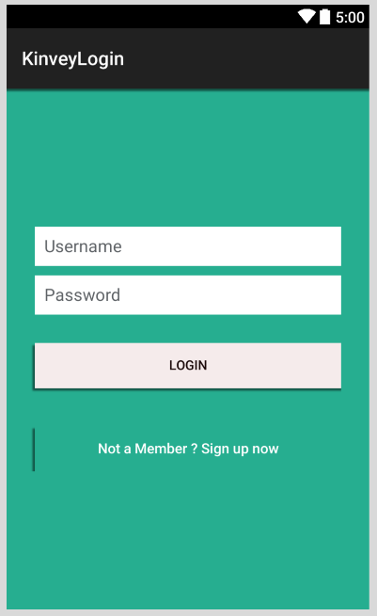 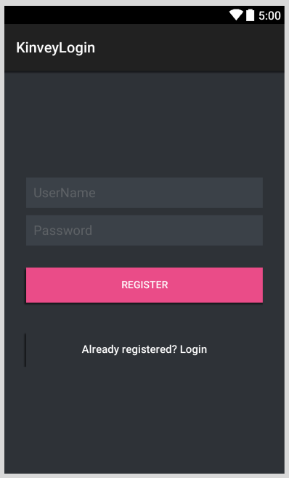

**Main.axml Register.axml**

Go to Kinvey.com and create your new app

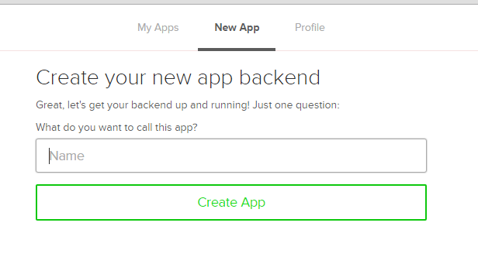

Follow the steps from your previous project.

1. Next we need to setup the Kinvey library

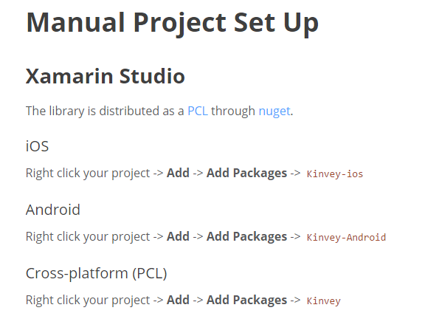

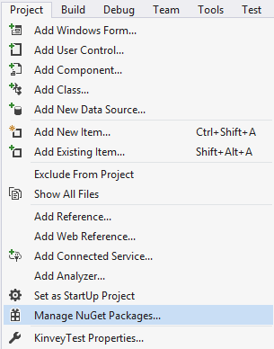

1. Search for Kinvey Android and click Install

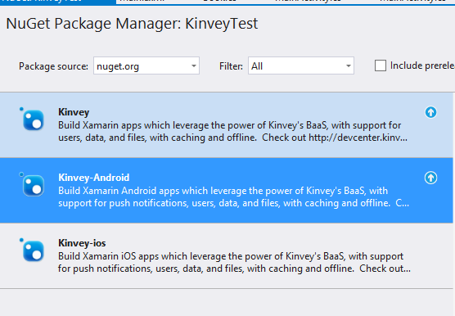

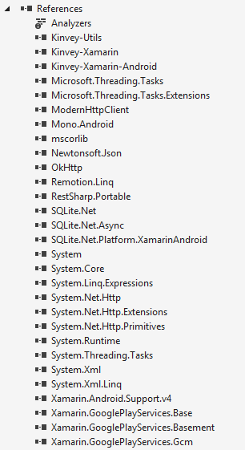

1. Solve any errors that you may encounter with the installation of Kinvey Library
2. Finding out your API keys

In your Kinvey dashboard, click on the link at the bottom which says API Keys.

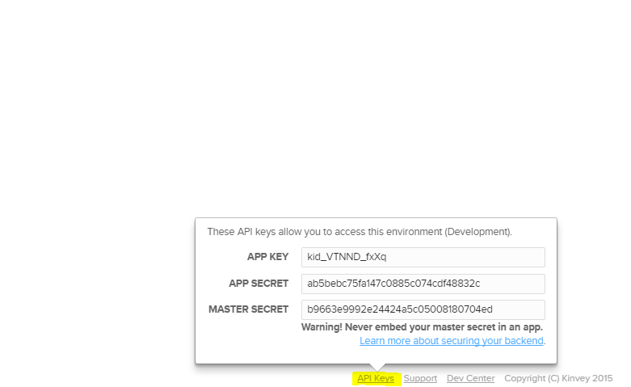

Copy the app key and the app secret

**Registering a New User**

**MainActivity.cs**

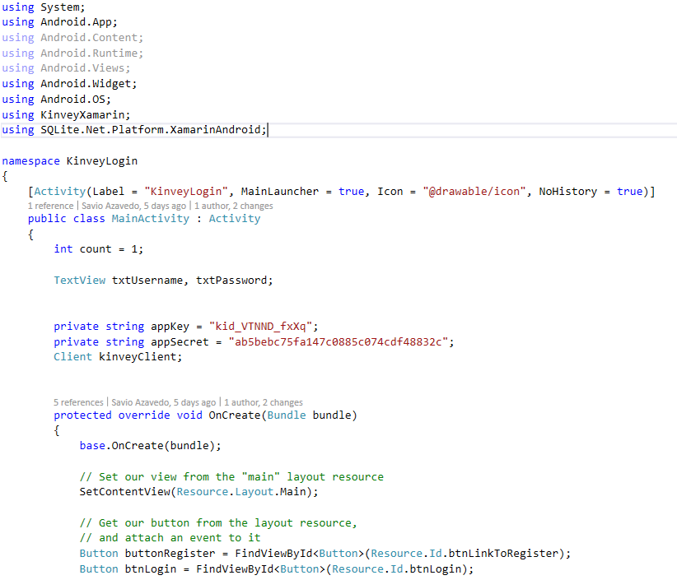

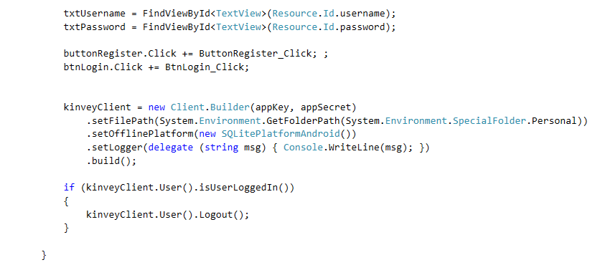

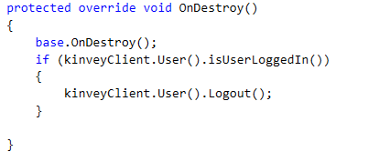

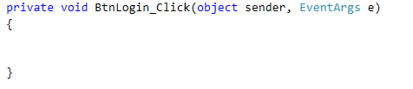

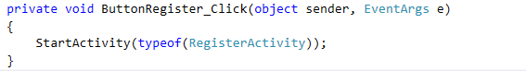

**Add a new class RegisterActivity.cs**

**RegisterActivity.cs**

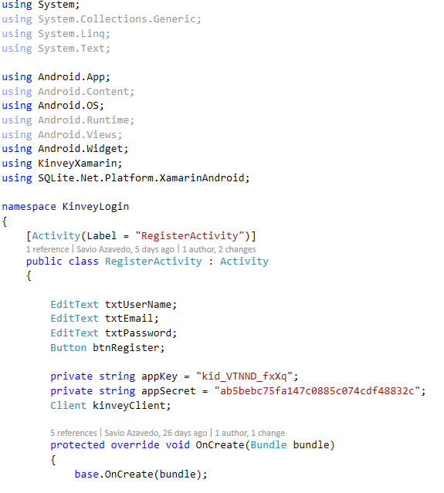

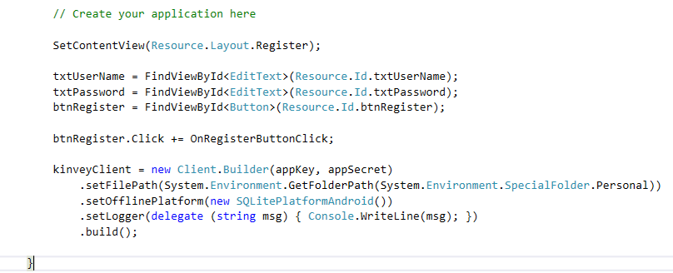

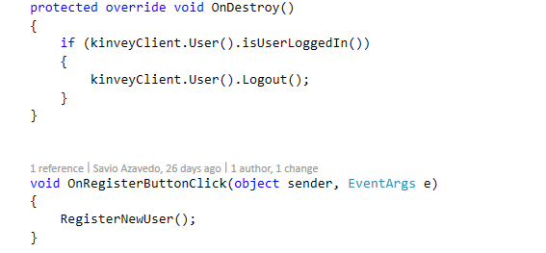

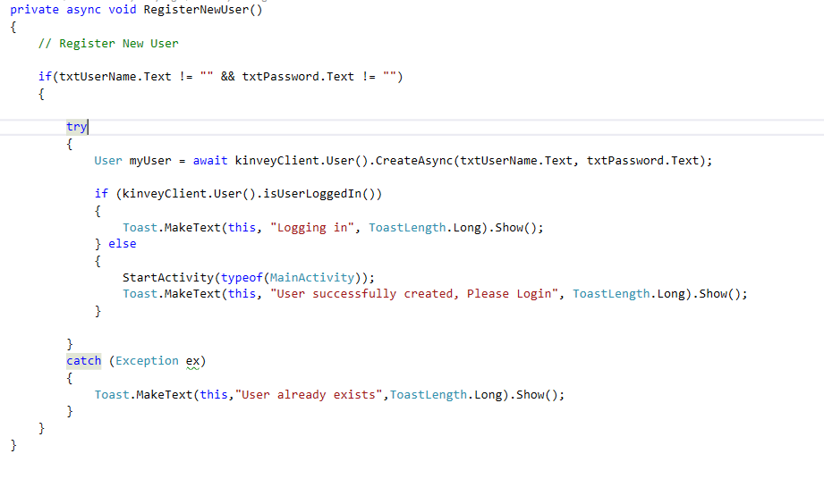

**Add some users**

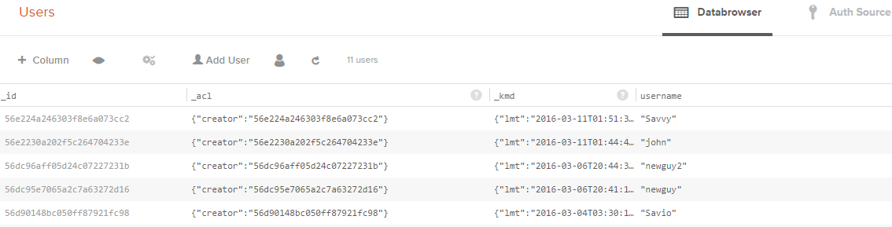

**Test the Login Screen**

**MainActivity.cs**

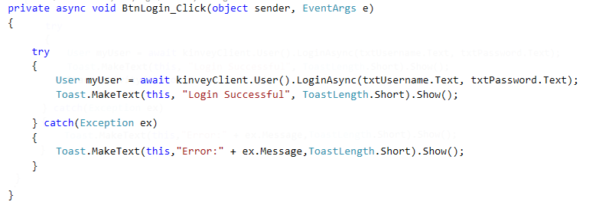

Add,Edit,Delete and View to-do items for individual users

Create a new layout **ToDo.axml**

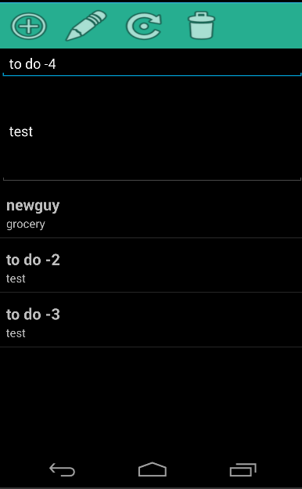

**ToDo.axml**

**ToDoActivity.cs**

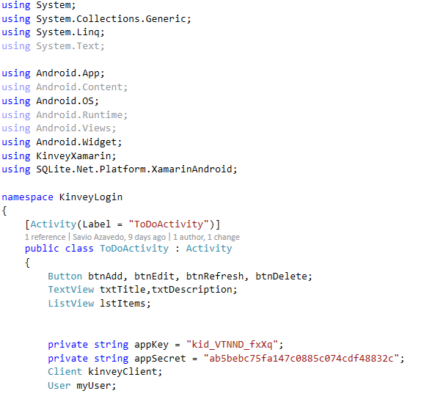

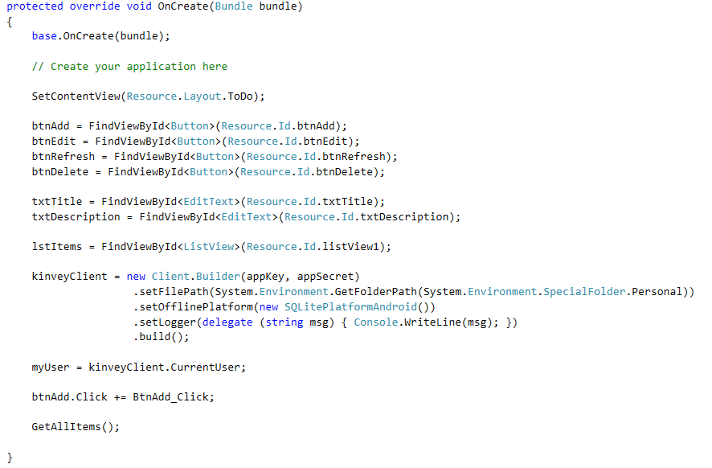

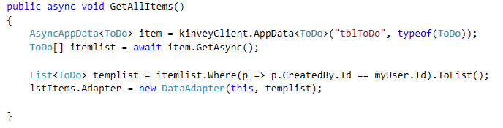

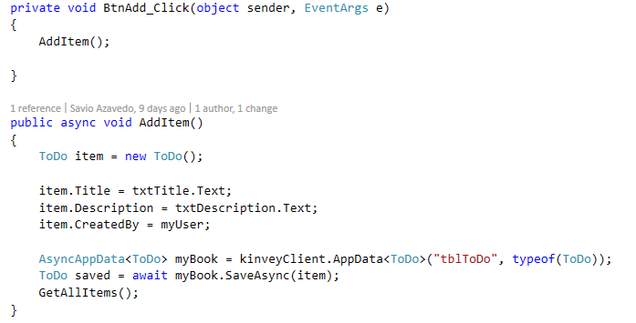

**Exercise**

**Complete the following functions**

